Project Design Phase-II
Technology Stack (Architecture & Stack)
Date | 06 February 2026
Team ID | LTVIP2026TMIDS66306
Project Name | Gemini historical artifact description
Maximum Marks | 4 marks

Technical Architecture:
The Deliverable shall include the architectural diagram as below and the information as per the table1 & table 2

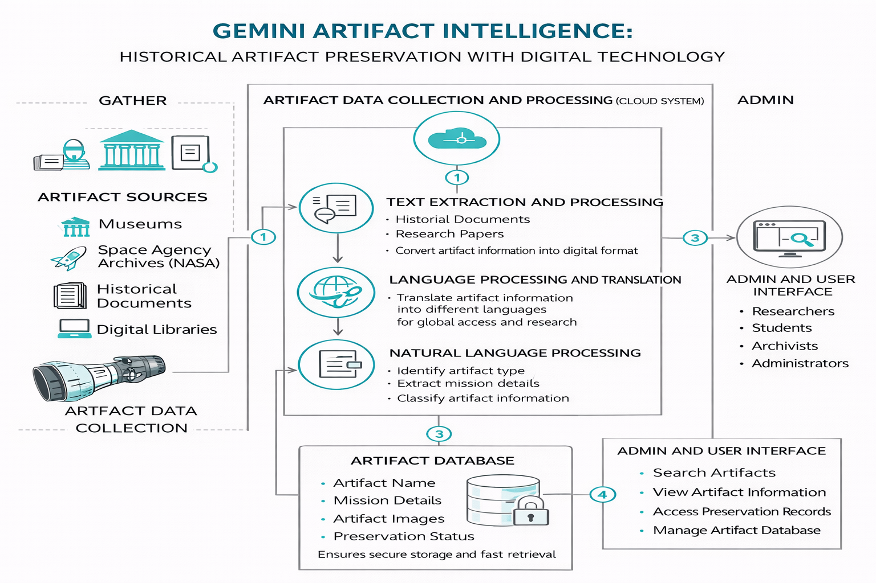

Table-1 : Components & Technologies:

S.No | Component | Description | Technology
1. | User Interface | Critical element designed for both Traffic Managers and everyday users, ensuring an intuitive and informative experience. | HTML, CSS, JavaScript
2. | Application Logic-1 | Involves a robust backend system responsible for processing, analyzing, and managing traffic data. | Python
3. | Database | Involves the storage and management of diverse traffic data for analysis. | File Manager, csv
4. | File Storage/ Data | Involves managing diverse types of data, including raw traffic data, models, and configuration files. | Local System, Google Drive
5. | Frame Work | It is a crucial part of our program as it is responsible for connecting the frontend with the backend. | Python Flask

Table-2: Application Characteristics:
S.No | Characteristics | Description | Technology
1. | Open-Source Frameworks | Open-source frameworks can accelerate development and ensure the reliability of Gemini. | Python’s Flask
2. | Scalability | Using cameras to collect data and to make models for specific locations. | Computer vision, dynamic databases.
3. | Performance | Regular performance testing, monitoring, and optimization are integral components of the development and maintenance processes | R squared, Root mean squared error, Root Mean Square deviation
4. | Availability | Website can be made available all time in a webserver. This makes the website running without any issues | High speed Linux based webservers.

